Business Requirement Document
Educational Academy Platform

Prepared by: mohamed adel khalifa
ITI BRD

Version: V0.1

Document Change Record
Version Number | Date | Description
0.1 | 02/09/2025 | First draft document
0.2 | 06/09/2025 | Functional Requirements
1.0 | 10/09/2025 | Initial Document

Table of Contents
1 Introduction 1
1.1. Situation Statement 1
1.2. referenced documents 1
1.3. Scope 1
2 business requirements 2
3 nonfunctional requirements 2
4 Functional Requirements 2
4.1. Requirement Category 1 2
4.2. Requirement Category 2 3
4.3. Reporting and Analysis Requirements 4
4.4. Alerting and Collaboration Requirements 6
4.5. Security Requirements 7
<Attach the Roles-Permission Matrix> 7
4.6. Integration Requirements 8
5 Transition Requirements 8
6 Product information 8
6.1. Business Rules 8
6.2. Constraints 8
6.3. Assumptions 8
6.4. Issues 8
6.5. Risks 8
7 Data Requirements 8

List of Tables
Table 1: Business Requirements 4
Table 2: Nonfunctional Requirements 4
Table 3 : Requirement category 1 5
Table 4 : requirement category 2 6
Table 5 : Reporting And Analysis Requirements 7
Table 6 : Alerting And Collaboration Requirements 9
Table 7 : Security Requirements 10
Table 8 : Integration Requirements 11

List of Figures
No table of figures entries found.

Introduction
This document defines the business requirements for implementing a comprehensive Digital Academic Management Solution that addresses these challenges. The solution will provide dynamic course catalogue management, a Student Information System (SIS), a Learning Management System (LMS) for both students and instructors, a content management platform for marketing, and compliance with relevant KSA digital education regulations.

The proposed platform will streamline processes, reduce redundancies, increase student engagement, and align with the digital vision of the academy, ensuring scalability for future growth such as online payment support.

Situation Statement
Currently, the academy is experiencing the following challenges and limitations with its existing digital process:
Low website engagement and traffic due to static, outdated content and weak user experience.
Complex and unfriendly registration process, leading to high bounce rates, missing applicants, and preference for manual in-person registration.
Limited digital marketing capability, with no dynamic tools to promote courses, events, or live activities.
Manual student management, resulting in inefficiencies in admission, approval workflows, and record keeping.
Lack of a unified platform for instructors and students to perform teaching and learning activities (course material, assignments, attendance, evaluations).
Data entry redundancies, creating operational inefficiency and risk of error.
Non-compliance with new digital education policies, including requirements from the National eLearning Center (unified student profile, parental approval for underage applicants, and NAFATH ID integration).
Absence of analytics, preventing the academy from measuring website performance, user behavior, and student engagement.
These challenges impact the academy’s ability to scale, attract students, and provide a high-quality, competitive education experience in line with modern digital academic standards.

referenced documents
The BRD references and is written with compliance to the following documents:
- Glossary

- Capability Table

- Stakeholder Register

- Stakeholder Register
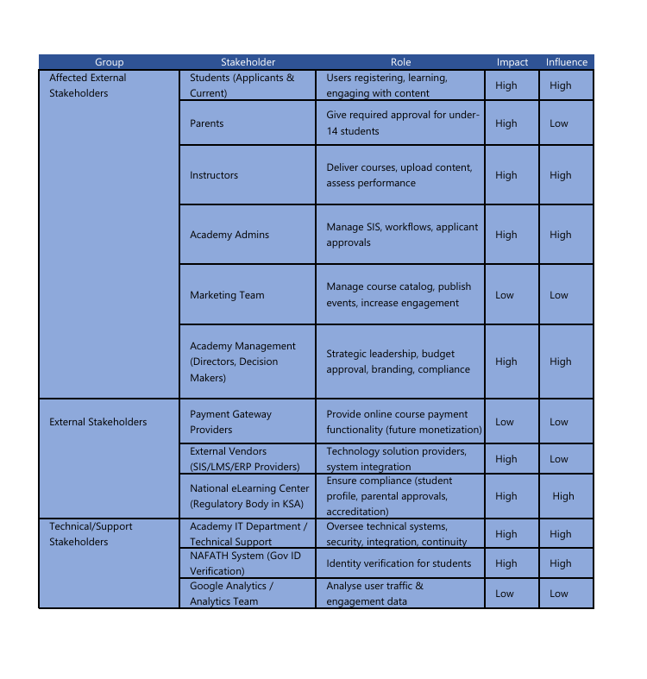

- Product Roadmap

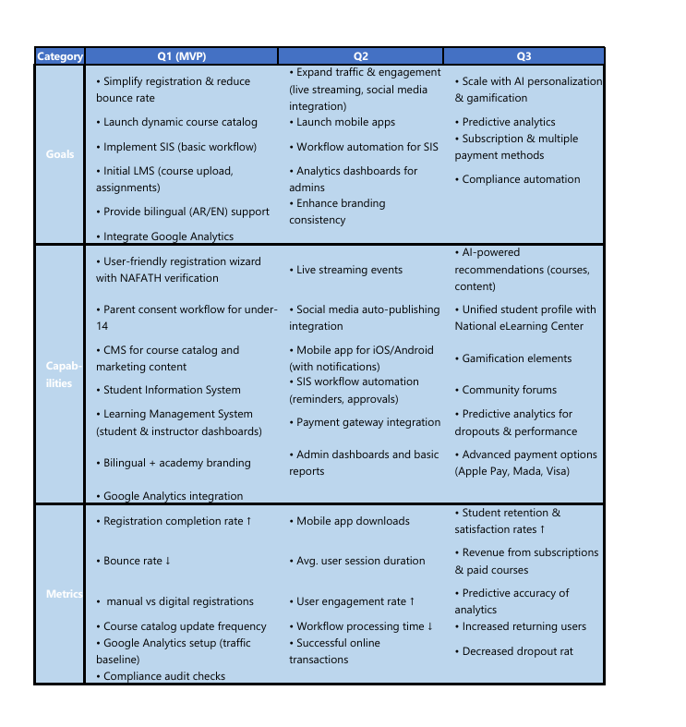

- Capability Table
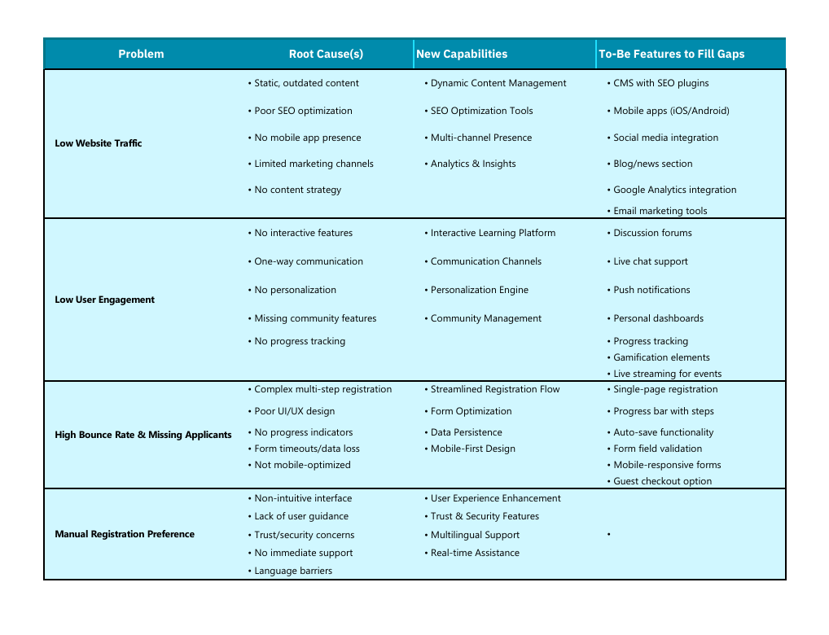

Scope
The scope of this project is to design, develop, and implement a comprehensive Digital Academic Management Platform for the educational academy in the Kingdom of Saudi Arabia (KSA). The solution will replace manual and fragmented processes with a modern, fully integrated digital ecosystem.

- This initiative will encompass the following solution areas:

1. Course Catalogue & Website Management
- 1.1 Provide a dynamic course catalogue system to allow the marketing team to:
- Create, edit, and delete courses.
- Mark specific courses as featured.
- Immediately publish updates online (no developer involvement required).

- 1.2 Introduce search and filtering capabilities for students to easily locate courses by topic, schedule, instructor, or delivery mode.
- 1.3 Integrate with a Content Management System (CMS) to:
- Publish academy announcements, blogs, multimedia content, and event updates.
- Support live-streaming of academy events directly on the academy’s website.
- Enable scheduling of content for future publication.

2. Student Information System (SIS)
- 2.1 Implement an end-to-end student admission workflow:
- Digital course registration with simplified, user-friendly forms.
- Application review and approval workflow for academy administrators.
- Automatic notification to applicants upon approval/rejection.

- 2.2 Ensure regulatory compliance with National eLearning Center standards:
- Unified student profile across all systems.
- Parent/guardian approval process for students younger than 14 years of age.
- Integration with the NAFATH ID verification system for authenticating applicants.

- 2.3 Provide role-based dashboards for the SIS:
- Admin dashboard for admissions, reporting, and oversight.
- Student portal for application tracking, enrollment confirmation, and profile management.

3. Learning Management System (LMS)
- 3.1 Provide student learning access:
- Course materials (documents, multimedia).
- Assignment submissions and deadline management.
- Attendance tracking and absence notifications.
- Performance tracking (grades, progress charts, feedback).

- 3.2 Provide instructor tools:
- Upload and manage course materials.
- Create and evaluate assignments/quizzes.
- Mark attendance.
- Monitor and evaluate student progress throughout the semester.

- 3.3 Develop a mobile application for iOS and Android:
- Student features (course content, assignments, schedules, notifications).
- Instructor features (attendance logging, course uploads, assignment grading).
- Offline mode for minimal functions during network loss.
4. Payment Processing & Financial Readiness
- 4.1 Integrate an online payment gateway for course fees with the following conditions:
- Free courses will remain unenforced (no charge).
- Architecture prepared for future paid courses (credit/debit cards).
- Payment history available within student profiles.

- 4.2 Support cancelation fee flagging (as a system attribute, with pricing handled externally).
5. Branding, User Experience & Accessibility
- 5.1 Ensure the platform reflects academy branding, including logos, themes, and design style, across all interfaces (web and mobile).
- 5.2 Provide a bilingual interface (Arabic and English) with seamless toggling between languages.
- 5.3 Apply user experience best practices:
- Intuitive navigation to reduce bounce rates.
- Smoother registration flows compared to the legacy website.
- 5.4 Ensure accessibility compliance (WCAG 2.1 standards), accommodating users with disabilities.
6. Security, Compliance & Access Control
- 6.1 Support role-based access control (RBAC):
- Roles: Administrator, Instructor, Student, Marketing Team.
- Enforce least-privilege principles (users only access what is relevant).
- 6.2 Ensure compliance with Saudi national regulations and policies on eLearning and data privacy.
- 6.3 Apply data security measures:
- Encrypt personally identifiable data (PII) in transit and at rest.
- Secure authentication with multifactor support.
7. Analytics & Reporting
- 7.1 Integrate Google Analytics for web performance monitoring (traffic, bounce rates, engagement metrics).
- 7.2 Develop reporting dashboards for administrators:
- Enrollment and course registration numbers.
- Student activity and engagement levels.
- Instructor performance indicators.
- 7.3 Allow export of reports in PDF and Excel format for management use.
8. Data Management & System Integration
- 8.1 Design to eliminate redundant data entry with centralized and consistent data flow between SIS, LMS, and CMS modules.
- 8.2 Support data reconciliation during outages (temporary offline data caching, sync upon network restoration).
- 8.3 Provide safe archival and daily backup of student and academic data with disaster recovery capabilities.
9. Out of Scope (Exclusions)
- Pricing policy calculation logic (handled separately by the Pricing & Finance Team).
- ERP or HR system integration (may be considered for future phases).
- Non-educational third-party integrations (outside SIS/LMS scope).
- Physical infrastructure setup (to be determined as cloud-first solution).

business requirements
This section covers the high-level business goals and objectives that provide the rationale for building the solution.

Table 1: Business Requirements
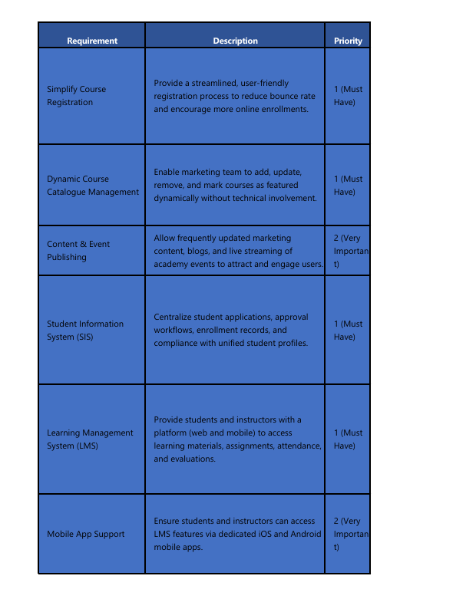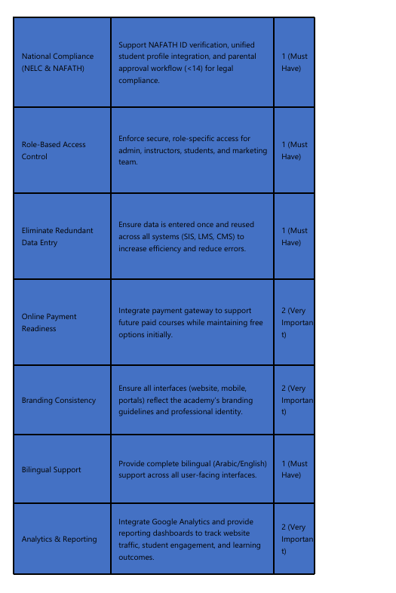

nonfunctional requirements
Table 2: Nonfunctional Requirements
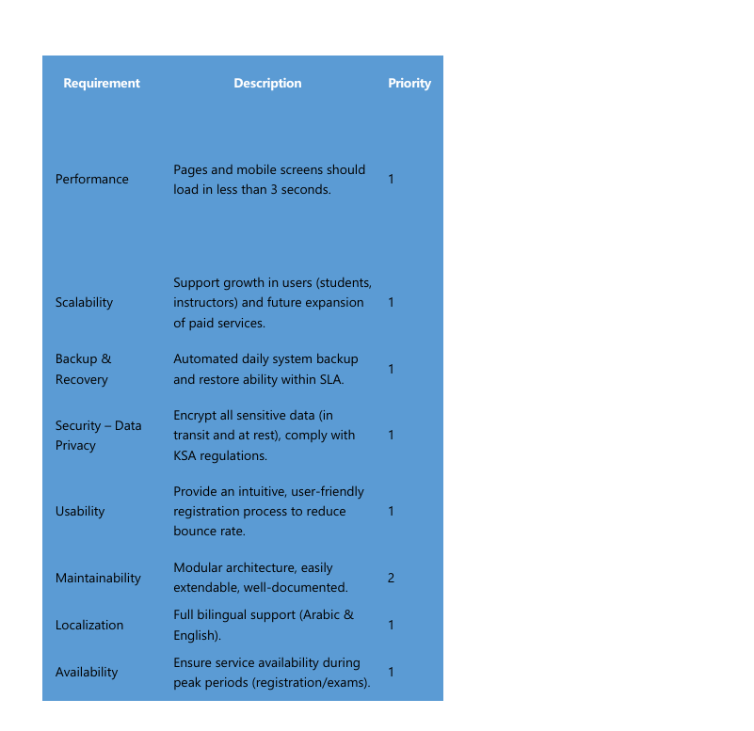

Functional Requirements
The core functional requirements of the solution are categorized and structured as shown in the sub sections.

Each requirement listed in section 4.0 will be evaluated on a scale of 1-3 as described below:
Rating System:
Priority: 1 = Must Have, 2 = Very Important, 3 = Nice to Have

<Attach to each requirement category models that represents them such as use case diagram, process flow>

<For a more detailed BRD, document the use case of each requirement>

Requirement Category 1
Table 3 : Requirement category 1
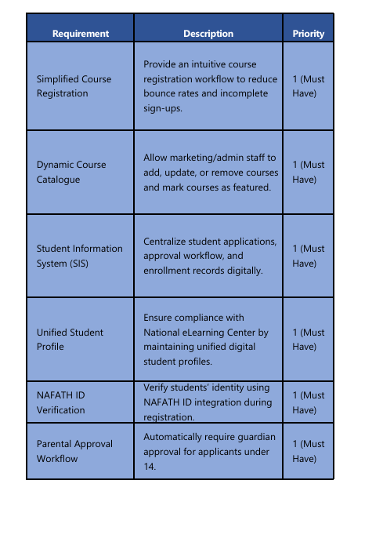

Table 4 : Requirement category 2
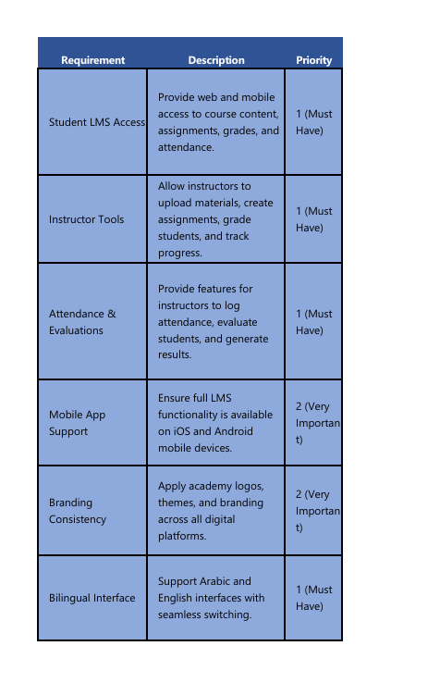

Table 5 : Requirement category 3
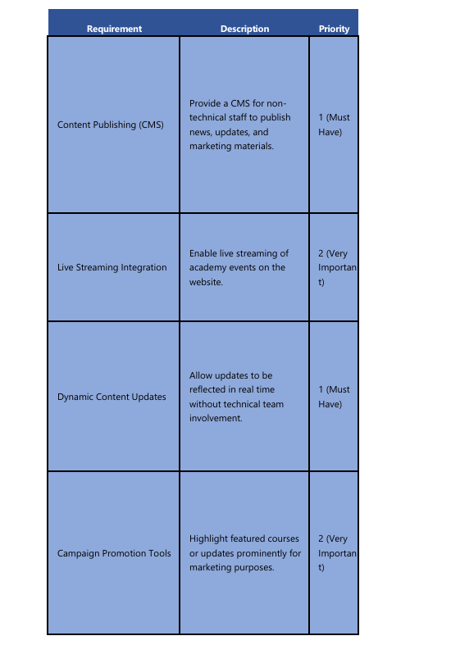

Table 6: Reporting And Analysis Requirements
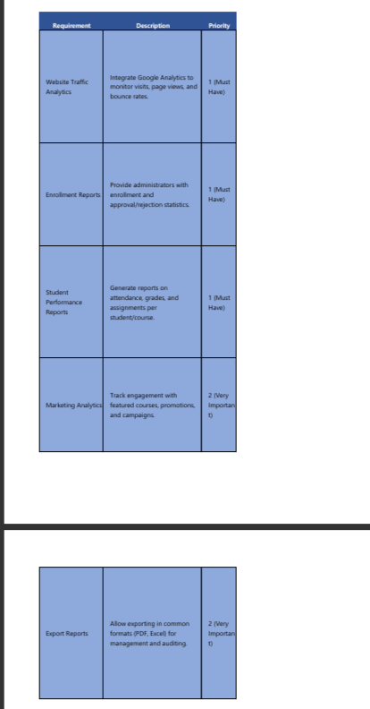
Table 7 : INTEGRATION REQUIREMENTS
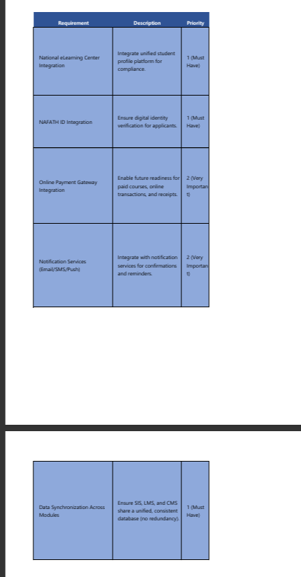

User Management Requirements
Table 8 : Security Requirements
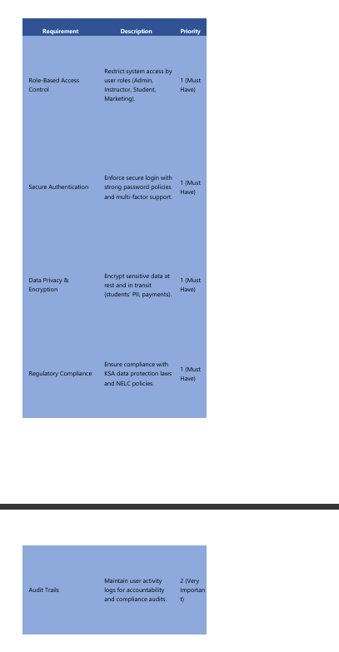

Product information

Business Rules

Constraints

Assumptions

Issues

Risks

Data Requirements
<Attach the ERD>

8 Scope Models

CONTEXT DIAGRAM
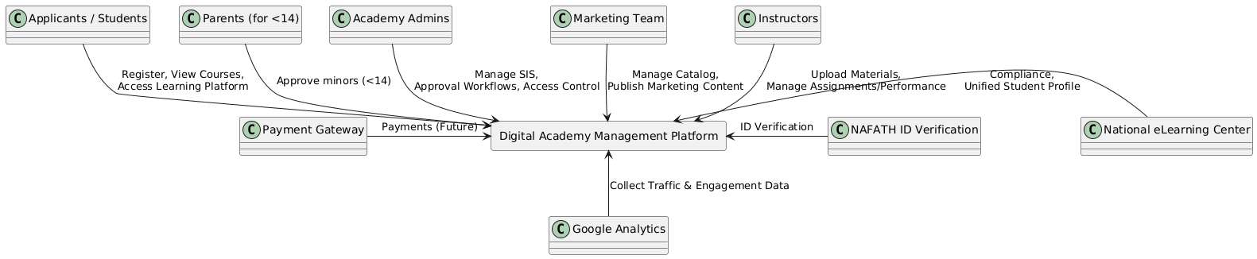

Use case
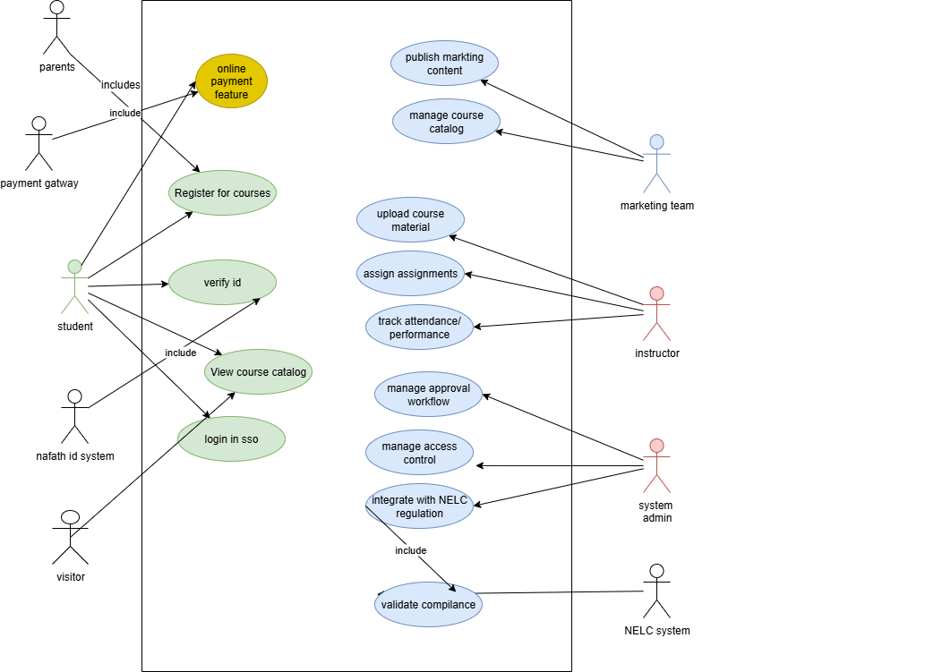

Activity diagram
